0 Welcome!
Date
Name
Spouse
Address
City
State Zip _________
Email

Please Contact By
❑ Card  Phone  Visit

Telephone Best Time to Call
Home ______________
Work ______________

Guest: First Time Second Time
Are you a church member: yes no
Church
City, State

Circle Appropriate Age/Grade Group(s)
Preschool: Ages: B-1 2-3 4-5
Children: Grades: K 1 2 3 4 5 6
Youth: Grades: 7 8 9 10 11 12
Adults: Ages:18-29 30s 40s 50s 60s+

How did you learn about our church?
Newspaper Friend Yellow Pages Mail
Other

I am a guest of:

New in the Community? Yes No
Names & ages of children at home

Weekly Service & Activity Schedule

July 9, 2017
9:30 a.m. New Commandment Kids
9:45 a.m. Sunday School
11:00 a.m. Worship Service
12:00 pm Potluck Lunch
6:00 p.m. “The Burden of Pride”/Business Meeting

Week of July 9, 2017
Wednesday 6:30 pm………………..…Meal/Bible Study
Friday 6:30 pm……………..……………..Men’s 42 Night
July
16-20…………………….……………Vacation Bible School
23…………………………………….…………Lord’s Supper
25………………………………….Make & Take Card Class
26……………………………..…………..Summer Fun Days
30……………………………Lynette Johnson Worship Svc
30 – Aug 2……………………….…………..Pre Teen Camp
Make & Take Card Class “Christmas in July” Tuesday July 25, 6:00 pm – 9:00 pm The cost is $20 and attendees will take home 4 cards Contact Brenda Williams if you are interested 512-925-8572

Summer Fun Days Celebration!! WATER DAY!! July 26, 9:00 am – 1:00 pm Pizza and snacks will be provided!! Bring your swim clothes and a towel

Join us as we welcome Lynette Johnson to our worship service Sunday July 30. She will be sharing her testimony and her music.

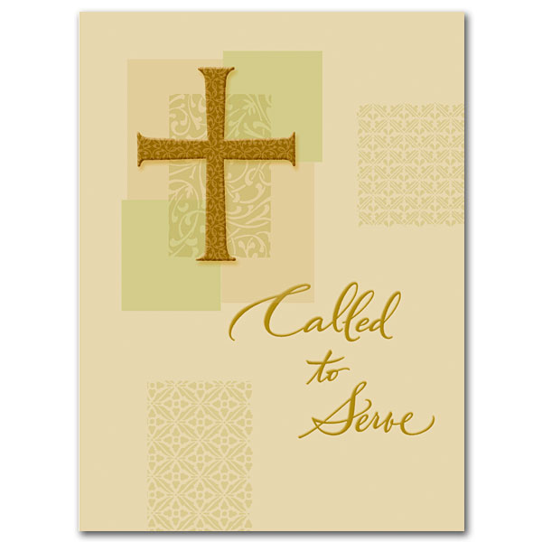

Knobbs Springs Baptist Church

July 9, 2017

Church Information:

KnobbsSpringsBC.com KnobbsSpringsBaptist@gmail.com

1662 CR 305, McDade, Texas 78650 512-273-2743

David Atwood, Pastor Cell 512-470-5098

Patti Radford, Office Manager Cell 512-968-7821

